
KOKORO CUP 2013
30th November of 2013
Sports Hall Staffa 3/5
in Warsaw, Poland
OFFICIAL INVITATION LETTER

OSU!
Dear friends of Karate Kyokushin and Shinkyokushin,
Country representatives, Branch chiefs,
Shihan, Sensei and Sempai,

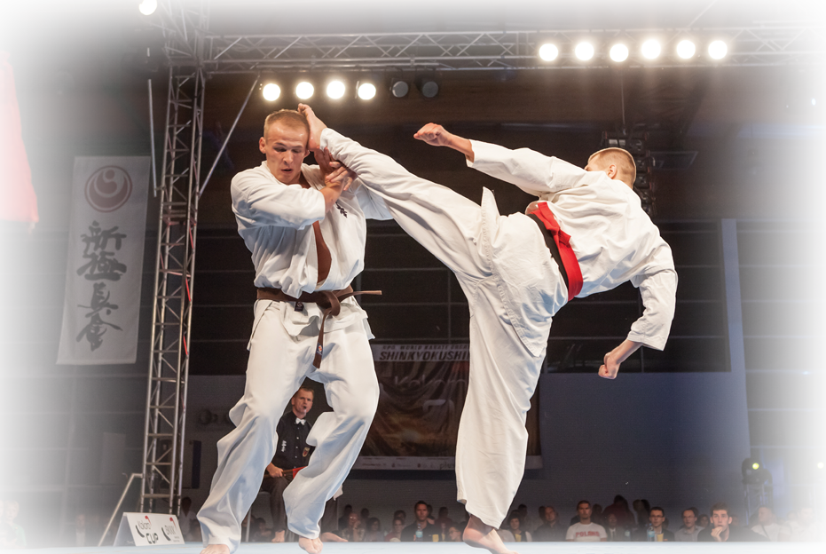

Bielanski Klub Kyokushin Karate as the organizer guided by Brand Chief WKO sensei Mariusz Mazur (4 DAN) invites for KOKORO CUP 7

European fighters will compete for the Kokoro CUP in Kumite open weight category.
This tournament will take place in Warsaw, Poland in Sports Hall Staffa 3/5 on 30th of November 2013.

- Organizer:
Bielański Klub Kyokushin Karate Branch WKO sensei Mariusz Mazur (4 DAN)

- Date and place of the tournament:
Saturday, 30th of November 2013, Sports Hall Staffa 3/5, Warsaw, Poland

- Competition:
KUMITE FULL CONTAKT

- Registration:
The registration of participants can place no later than up to 30 August 2013 (Friday), 12 p.m. Organizer will cover costs of travel and stay in Warsaw to the best players 8. Applications received after this date will not receive a guarantee to cover the costs of participation in the Tournament.
Applications sent to turniej@karatebielanski.com.pl
mariusz@karatebielanski.com.pl

- The winner will receive the prize in the form of one-time grant of 1,000 EUR.

- General conditions of participation in the tournament:
Kokoro Cup – competition rules
Rules of fight - WKO rules of kyokushin full contact fight
Additional rules
- The competitor who lost his fight can fight next round of tournament if his opponent who won can’t fight.
- If final fight will not take place the competitors don’t get financial reward.
- Only groin protectors and mouthpiece can be used. Taping/bandage with tape is principally prohibited unless the Tournament Doctor gives a stamp of approval and main referee except this.

Fight time | Main Bout | Extension | The 2nd  Extension | Decision by  Weight | Final  Extension
All tournament | 2 minutes | 2 minutes | 2 minutes | 10 kg difference  Weight during tournament. | - minutes

- Documents required:
- Player’s personal questionnaire
- Health information
- Insurance
- Hotel booking

Please bring with them the flag of your country in standard-size.

Insurance: The executive committee would like to ask you to purchase insurances prior to arrival. Please note that insurances for sportsmen foresee special conditions. Make sure your insurance company has a representative in Poland

- The preliminary schedule:

The specific program will be announced after the close of the starting list 17 November 2013 (Sunday).

- Entry fee players must make the entry fee of 30 EUR.

- Awards:

For the first, second and third place - participants receive a trophy. Organizer provides all participants prizes.

- Sayonara-party for players, coaches and referees free.

- Accomodation:
Dobre Miejsce ul. Dewajtis 3 Warsaw 01-815, Poland
LIMITED BEDS!
PRICE: 70 PLN/ 20 EUR
Organizer covers the expenses of the eight players
www.dobre-miejsce.home.pl

Payments can be made by the Bank account:

Bielański Klub Kyokushin Karate
01-891 Warsaw
ul. L. Staffa 3/5
BZ WBK 93 1090 1014 0000 0000 0328 0351

Recomended hotels:
- IBIS WARSAW CENTER http://www.ibis.com/pl/hotel-2894-ibis-warszawa-centrum/index.shtml

- IBIS WARSAW OLD TOWN http://www.ibis.com/pl/hotel-3714-ibis-warszawa-stare-miasto-old-town/index.shtml
As organizers, we are counting on your participation, we hope that the tournament will be a great success. If you have any questions or if you need any additional information, do not hesitate to contact us.
We will be honored to welcome Europe’s finest and most skilled fighters to the city of Warsaw, Poland.

Sincerely yours,

Sensei Mariusz Mazur
Kokoro CUP Organizing Committee
mariusz@karatebielanski.com.pl
+48 602 315 601
More:
www.karatebielanski.com.pl
www.kokorocup.pl
KOKORO CUP 2013
30 th November of 2013
Sports Hall Staffa 3/5
in Warsaw, Poland

PLAYER’S PERSONAL QUESTIONNAIRE

NAME:
COUNTRY:
DOJO:
COATCH:
DATE OF BIRTH:
SEX: M/F*
GRADE: (DAN/KYU)*
HEIGHT:
WEIGHT:
* Delete as not necessary

Achievements in national and international tournament (including tournament, year and place):

HOBBY

PROFESSION

EDUCATION

Date: __________________ Signature: ___________________
Please send player’s personal questionnaire form to Organizer by 30 August 2013.

KOKORO CUP 2013
30 th November of 2013
Sports Hall Staffa 3/5
in Warsaw, Poland

HEALTH INFORMATION FORM
for fighters only

Health information for: _________________________________________________________
(Full name)

Do you use visual correction?
No/Yes* glasses Yes* contact lenses
Do you take any medicine for - (if yes, write medicine, doses, etc. on the back of this paper)
Diabetes? No/Yes*
Allergy? No/Yes*
Asthma? No/Yes*
Epilepsy? No/Yes*
Cardio-vascular disorders? No/Yes*
Do you use any other medication? No/Yes*
Have you been unconscious before? No/Yes*
When?
Do you suffer from any present or previous injuries? No/Yes*
Which
Do you feel in good health? No/Yes*
Other relevant health information:

If you are female:
Pregnant/signs of pregnancy?
No/Yes*= PARTICIPATION NOT ALLOWED

Incorrect or missing statements may cause rejection of your participation in „Kokoro CUP 2013” tournament. Participation in the tournament is at the fighters own risk.

I accept the statements above and declare my information to be correct.

Date: _________ Signature:

Please send health information form to Organizer by 1 November 2013.

KOKORO CUP 2013
16 th November of 2013
Sports Hall Staffa 3/5
in Warsaw, Poland

HOTEL BOOKING FORM

Hotel: Dobre Miejsce ul. Dewajtis 3 Warsaw 01-815, Poland
LIMITED BEDS!
PRICE: 70 PLN/ 20 EUR
Organizer covers the expenses of the eight players
www.dobre-miejsce.home.pl

Payments can be made by the Bank account:
Bielański Klub Kyokushin Karate
01-891 Warsaw
ul. L. Staffa 3/5
BZ WBK 93 1090 1014 0000 0000 0328 0351

_ Name and address of the Club represented _
_Contact person_
_Contact_

No. Full nameOfficial
Coach
Fighter
SupporterARRIVAL
(date)DEPARTURE
(date)TOTAL DAYS

RATE

TOTAL1 20 EUR234
Date:__________________Signature:___________________
Please send hotel booking form to Organizer by 30 August 2013

Recomended hotels:
IBIS WARSAW CENTER HYPERLINK "http://www.ibis.com/pl/hotel-2894-ibis-warszawa-centrum/index.shtml" http://www.ibis.com/pl/hotel-2894-ibis-warszawa-centrum/index.shtml
IBIS WARSAW OLD TOWN HYPERLINK "http://www.ibis.com/pl/hotel-3714-ibis-warszawa-stare-miasto-old-town/index.shtml" http://www.ibis.com/pl/hotel-3714-ibis-warszawa-stare-miasto-old-town/index.shtml

